Brad G. Skidmore
9291 Race St
Thornton Colorado
E-mail: excelwork@hotmail.com
Web: http://www.tou.com/host/Batfly
Phone: 303 227 0126 (Cell 204 9180)
Fax: 303 286 2893

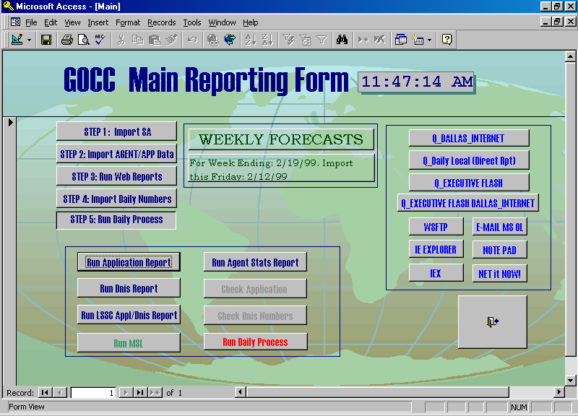
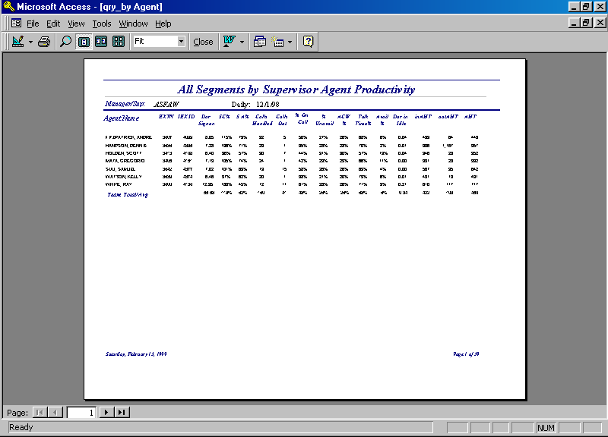
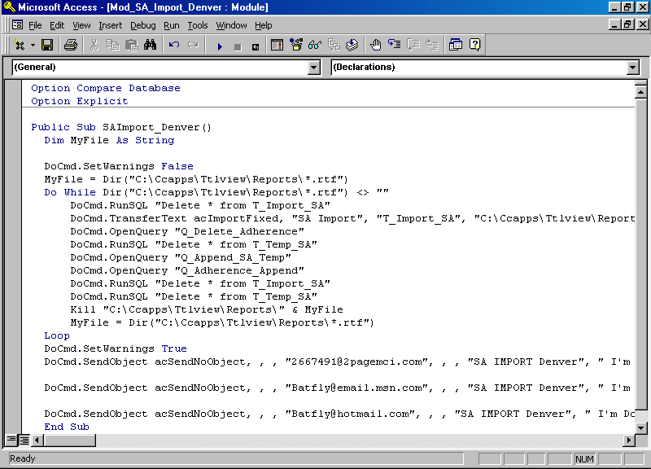
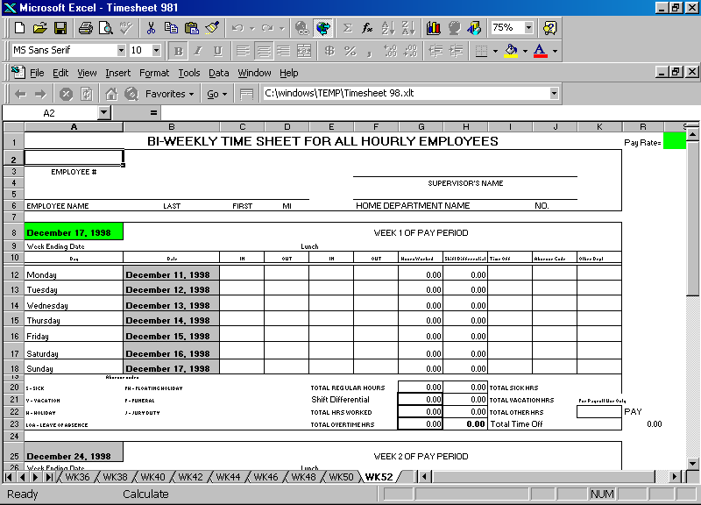

JOB TARGET: Systems Analyst / MS Access Excel Developer

ACCOMPLISHMENTS

- SAS Certification
Enterprise Reporter: Creating Business Reports.
Awarded 1.2 CEU's / 12 CPE's February 17, 1999.

- Used Technology
Designed various MS Access databases and Excel Spreadsheets (including pivot tables) with module and macro programming to work with different sources of data (Aspect - Informix-ODBC, Spectrum-RDBS-ODBC, Lucent- Centre-Vu vs. 5.0). These systems were developed to track several hundred call center agents with various reports ranging from attendance tracking, schedule adherence, headcount, payroll accounting, incentive programs and ACD (Automated Call Disposition) statistics. A unique feature of these systems is that they are timer activated to automatically process and distribute reports via e-mail to multiple recipients with differing schedules.

- HTML
Web Pages: Atria Northglenn and Pioneer House Restaurant.
(http://www.tou.com/host/Atria)
(http://www.tou.com/host/PioneerHouse)

WORK HISTORY

SEP 98 - Present
- Report Analyst MCI WorldCom: Highlands Ranch Colorado
Responsible for designing utilizing and linking Access databases to Oracle and Informix databases. Program Visual Basic Modules to automate launching other applications (IEX, NET-IT-NOW, All Microsoft Office Applications, or any windows based applications) to run and import desired reports into viable data. These Access databases are used to track application call statistics, agent performance as well as schedule adherence. I edit HTML when needed and FTP all reports to the Web on a daily basis. As well as producing established reports, I constantly provide ad-hoc reports on demand.

DEC 97 – DEC 98
- Consultant: MS Access, Excel, and Visual Basic programming
Consulted for the City of Thornton, Atria Northglenn,
Manor Health Care Marietta Georgia, and Pioneer House Restaurant Wenatchee Washington. Designed spreadsheets with Macro programming to track Salary information, Budget plans, and various scheduling tables. Designed Web pages for:
Atria Northglenn (http://www.tou.com/host/Atria)
Pioneer House Restaurant (http://www.tou.com/host/PioneerHouse)

MAR 96 – SEP 98
- TeleTech Holdings Call Center: Thornton Colorado
- Command Center Supervisor (Promotion NOV 97)
- Command Center Coordinator (Promotion NOV 96)
- Customer Service Representative (MAR 96 – NOV 96)
As a Command Center Supervisor I monitored multiple
Clients (Microsoft, Nextel, Bell Atlantic, Business Travel Solutions, Novell, National Mortgage, US West, and GTE INS) to report any vital service level affecting issues to various project managers, supervisors, and corporate clients. Responsibilities included managing agent staffing levels and supervising Command Center Coordinators. As well, I developed MS Access databases and Excel spreadsheets to provide vital analysis of data.

NOV 89 – NOV 95
- Airborne Hebrew Linguist
- United States Air Force: RAF Mildenhall United Kingdom
Transcribe Hebrew voice communications to English transcripts. Operate intelligence collection systems. Maintain order of battle database. Compile real time critical intelligence reports for theatre consumers and The National Security Agency.
EDUCATION

APR 91 – JUN 91
- USAF Survival School: Spokane Washington
Wilderness survival training. Water/Food procurement,
Shelter building. Prisoner of War training. Interrogation
resistance. Escape and evade training.
NOV 89 – APR 91
- Defense Language Institute: Monterey California
Associates - Hebrew
Intensive language training regiment: 8 hours a day 5 days a week for 47 weeks. Included Middle East history
and culture/communications and intelligence collection.
SEP 85-MAY 89
- Ridgefield High School: Ridgefield Washington
HS/Diploma – Algebra / Calculus
Graduated with 3.6 GPA.

SECURITY CLEARANCE: US GOVERNMENT TOP SECRET / SCI

References:

MCI WorldCom Teletech City of Thornton
Manager GOCC Manager OCC Controller
Elizabeth Watson Christie Davenport Ed Finger
(303) 738-1026 (303) 853-5237 (303) 538-7377

